公文管理系统

使用到的技术
Spring+Struts2+Hibernate
Mysql数据库
操作系统 win7 32位
服务器 Tomcat6.0

业务分析

类的设计
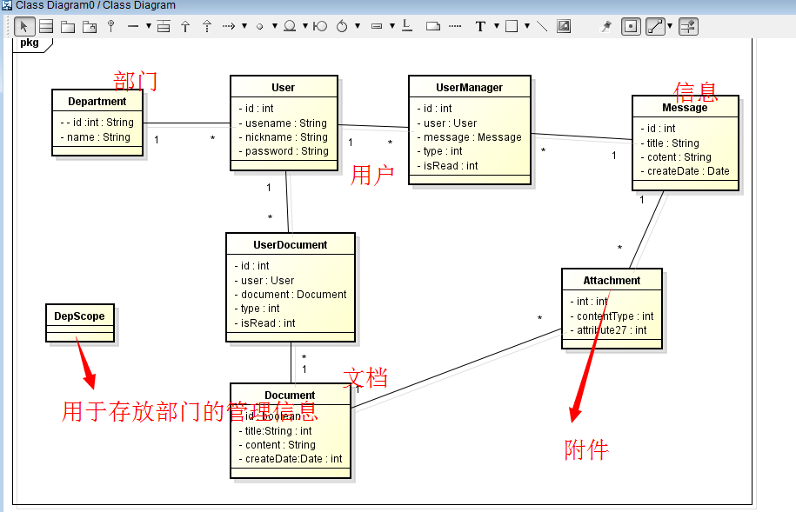
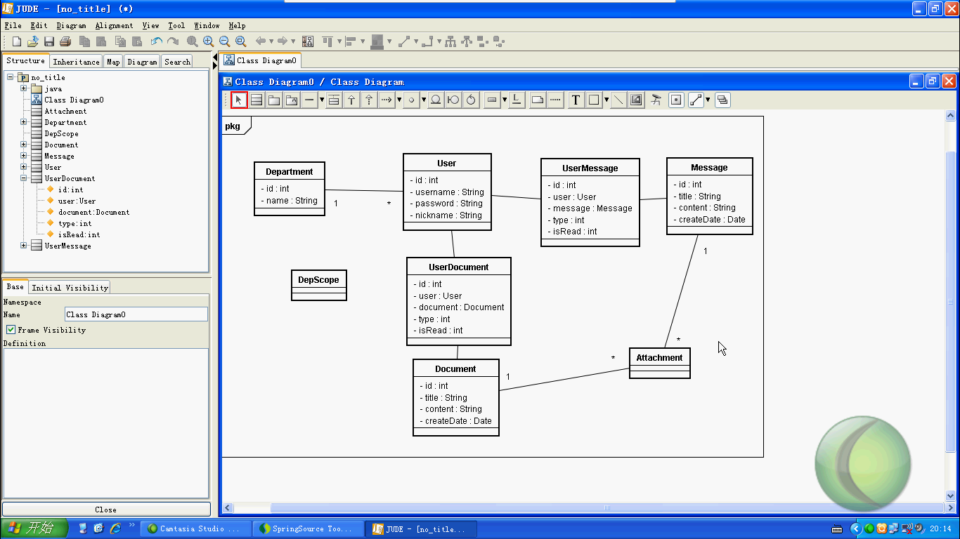

Model 层
User
Department
Document
Message
Attachment
DepScope

Department
package com.yellowcong.model;

import javax.persistence.Column;
import javax.persistence.Entity;
import javax.persistence.GeneratedValue;
import javax.persistence.Id;
import javax.persistence.Table;

@Entity
@Table(name="t_department")
public class Department {
private int id;
/**
* 公司的名称
*/
private String name;

/**
* @return the id
*/
@Id
@GeneratedValue
public int getId() {
return id;
}
/**
* @param id the id to set
*/
public void setId(int id) {
this.id = id;
}
/**
* @return the name
*/
@Column(length=32)
public String getName() {
return name;
}
/**
* @param name the name to set
*/
public void setName(String name) {
this.name = name;
}
/* (non-Javadoc)
* @see java.lang.Object#hashCode()
*/
@Override
public int hashCode() {
// TODO Auto-generated method stub
return 10000+id;
}
/* (non-Javadoc)
* @see java.lang.Object#equals(java.lang.Object)
*/
//当ID 相同的时候，两个对象相等
@Override
public boolean equals(Object obj) {
// TODO Auto-generated method stub
Department dep = (Department) obj;
if(dep.id == this.id) return true;
return false;
}
}

User
package com.yellowcong.model;

import javax.persistence.Column;
import javax.persistence.Entity;
import javax.persistence.GeneratedValue;
import javax.persistence.Id;
import javax.persistence.JoinColumn;
import javax.persistence.ManyToOne;
import javax.persistence.Table;

/**
*
* @author 狂飙のyellowcong 2014年5月2日
*
*/
@Entity
@Table(name="t_user")
public class User {
private int id;
private String username;
private String password;
private String nickname;
//用户的类型
//其中 0 表示的是普通用户
private int type;
private String email;
private Department department;
public User() {
}

public User(int id) {
super();
this.id = id;
}

public User(int id, String nickname) {
super();
this.id = id;
this.nickname = nickname;
}
public String getEmail() {
return email;
}
public void setEmail(String email) {
this.email = email;
}
/**
* 用户类型，0表示普通用户，1表示管理员，管理员可以进行部门的添加，权限的分配等管理
* @return
*/
public int getType() {
return type;
}
public void setType(int type) {
this.type = type;
}
@Id
@GeneratedValue
public int getId() {
return id;
}
public void setId(int id) {
this.id = id;
}
@Column(length=32)
public String getUsername() {
return username;
}
public void setUsername(String username) {
this.username = username;
}
@Column(length=32)
public String getPassword() {
return password;
}
public void setPassword(String password) {
this.password = password;
}
@Column(length=32)
public String getNickname() {
return nickname;
}
public void setNickname(String nickname) {
this.nickname = nickname;
}

@ManyToOne
@JoinColumn(name="department_id")
public Department getDepartment() {
return department;
}
public void setDepartment(Department department) {
this.department = department;
}
}

DepScope
package com.yellowcong.model;

import javax.persistence.Column;
import javax.persistence.Entity;
import javax.persistence.GeneratedValue;
import javax.persistence.Id;
import javax.persistence.JoinColumn;
import javax.persistence.ManyToOne;
import javax.persistence.Table;

/**
* 用户部门的管理
* @author 狂飙のyellowcong 2014年5月2日
*
*/
@Entity
@Table(name="t_department_scope")
public class DepScope {

private int id;
private int depId;
/**
* 被管理的部门
*/
private Department scopeDep;

@Id
@GeneratedValue
public int getId() {
return id;
}
public void setId(int id) {
this.id = id;
}
/**
* 要设置的部门id
* @return
*/
@Column(name="department_id")
public int getDepId() {
return depId;
}
public void setDepId(int depId) {
this.depId = depId;
}
/**
* 可以发送信息的部门对象
* @return
*/
@ManyToOne
@JoinColumn(name="scope_department_id")
public Department getScopeDep() {
return scopeDep;
}
public void setScopeDep(Department scopeDep) {
this.scopeDep = scopeDep;
}
}

Message
package com.yellowcong.model;

import java.util.Date;

import javax.persistence.Column;
import javax.persistence.Entity;
import javax.persistence.GeneratedValue;
import javax.persistence.Id;
import javax.persistence.JoinColumn;
import javax.persistence.ManyToOne;
import javax.persistence.Table;

/**
* 其中Message 对象和Document 类似
* @author 狂飙のyellowcong 2014年5月2日
*
*/
@Entity
@Table(name="t_message")
public class Message {
private int id;
private String title;
private String content;
private Date createDate;
private User user;

public Message() {
}

public Message(int id, String title, String content, Date createDate,
User user) {
super();
this.id = id;
this.title = title;
this.content = content;
this.createDate = createDate;
this.user = user;
}

public Message(int id, String title, String content, Date createDate) {
super();
this.id = id;
this.title = title;
this.content = content;
this.createDate = createDate;
}

@ManyToOne
@JoinColumn(name="user_id")
public User getUser() {
return user;
}
public void setUser(User user) {
this.user = user;
}
@Id
@GeneratedValue
public int getId() {
return id;
}
public void setId(int id) {
this.id = id;
}
public String getTitle() {
return title;
}
public void setTitle(String title) {
this.title = title;
}
@Column(name="content",columnDefinition="text")
public String getContent() {
return content;
}
public void setContent(String content) {
this.content = content;
}

@Column(name="create_date")
public Date getCreateDate() {
return createDate;
}
public void setCreateDate(Date createDate) {
this.createDate = createDate;
}
}

Document
package com.yellowcong.model;

import java.util.Date;

import javax.persistence.Column;
import javax.persistence.Entity;
import javax.persistence.GeneratedValue;
import javax.persistence.Id;
import javax.persistence.JoinColumn;
import javax.persistence.ManyToOne;
import javax.persistence.Table;

/**
* 文档对象
* @author 狂飙のyellowcong 2014年5月2日
*
*/
@Entity
@Table(name="t_document")
public class Document {
private int id;
private String title;
private String content;
private Date createDate;
//创建的对象
private User user;
public Document() {
}
public Document(int id, String title, String content, Date createDate) {
super();
this.id = id;
this.title = title;
this.content = content;
this.createDate = createDate;
}
@ManyToOne
@JoinColumn(name="user_id")
public User getUser() {
return user;
}
public void setUser(User user) {
this.user = user;
}
@Id
@GeneratedValue
public int getId() {
return id;
}
public void setId(int id) {
this.id = id;
}
@Column(length=108)
public String getTitle() {
return title;
}
public void setTitle(String title) {
this.title = title;
}
@Column(name="content",columnDefinition="text")
public String getContent() {
return content;
}
public void setContent(String content) {
this.content = content;
}

@Column(name="create_date")
public Date getCreateDate() {
return createDate;
}
public void setCreateDate(Date createDate) {
this.createDate = createDate;
}
}

Attachment
package com.yellowcong.model;

import java.util.Date;

import javax.persistence.Column;
import javax.persistence.Entity;
import javax.persistence.GeneratedValue;
import javax.persistence.Id;
import javax.persistence.JoinColumn;
import javax.persistence.ManyToOne;
import javax.persistence.Table;

@Entity
@Table(name="t_attachment")
public class Attachment {
private int id;
private String newName;
private String oldName;
private String contentType;
private long size;
private Date createDate;
private Message message;
private Document document;
private String type;

@Id
@GeneratedValue
public int getId() {
return id;
}
public void setId(int id) {
this.id = id;
}

/**
* 附件的新名称，这个名称是不会重复的，可以通过uuid或者时间的毫秒数获取
* @return
*/
@Column(name="new_name")
public String getNewName() {
return newName;
}
public void setNewName(String newName) {
this.newName = newName;
}
/**
* 附件的原有名称
* @return
*/
@Column(name="old_name")
public String getOldName() {
return oldName;
}
public void setOldName(String oldName) {
this.oldName = oldName;
}
/**
* 附件的文件类型
* @return
*/
@Column(name="content_type")
public String getContentType() {
return contentType;
}
public void setContentType(String contentType) {
this.contentType = contentType;
}
/**
* 附件的大小，以字节为单位
* @return
*/
public long getSize() {
return size;
}
public void setSize(long size) {
this.size = size;
}
/**
* 附件的创建时间
* @return
*/
@Column(name="create_date")
public Date getCreateDate() {
return createDate;
}
public void setCreateDate(Date createDate) {
this.createDate = createDate;
}
/**
* 附件是属于哪一个消息或者文档的
* @return
*/
@ManyToOne
@JoinColumn(name="msg_id")
public Message getMessage() {
return message;
}
public void setMessage(Message message) {
this.message = message;
}
@ManyToOne
@JoinColumn(name="doc_id")
public Document getDocument() {
return document;
}
public void setDocument(Document document) {
this.document = document;
}
/**
* 附件的后缀名
* @return
*/
public String getType() {
return type;
}
public void setType(String type) {
this.type = type;
}
}

UserMessage
package com.yellowcong.model;

import javax.persistence.Column;
import javax.persistence.Entity;
import javax.persistence.GeneratedValue;
import javax.persistence.Id;
import javax.persistence.JoinColumn;
import javax.persistence.ManyToOne;
import javax.persistence.Table;

/**
* 专门用来存储，用户所接收的私人信件
* @author Administrator
*
*/
@Entity
@Table(name="t_user_message")
public class UserMessage {

private int id;
private User user;
private Message message;
private int isRead;

@Id
@GeneratedValue
public int getId() {
return id;
}
public void setId(int id) {
this.id = id;
}

@ManyToOne
@JoinColumn(name="user_id")
public User getUser() {
return user;
}
public void setUser(User user) {
this.user = user;
}
@ManyToOne
@JoinColumn(name="msg_id")
public Message getMessage() {
return message;
}
public void setMessage(Message message) {
this.message = message;
}
/**
* 该信件是否可读
* @return
*/
@Column(name="is_read")
public int getIsRead() {
return isRead;
}
public void setIsRead(int isRead) {
this.isRead = isRead;
}
}

UserDocument
package com.yellowcong.model;

import javax.persistence.Entity;
import javax.persistence.GeneratedValue;
import javax.persistence.Id;
import javax.persistence.JoinColumn;
import javax.persistence.ManyToOne;
import javax.persistence.Table;

/**
* 用户已经读过的公文
* @author Administrator
*
*/
@Entity
@Table(name="t_user_document")
public class UserDocument {
private int id;
private User user;
private Document document;

@Id
@GeneratedValue
public int getId() {
return id;
}
public void setId(int id) {
this.id = id;
}
@ManyToOne
@JoinColumn(name="user_id")
public User getUser() {
return user;
}
public void setUser(User user) {
this.user = user;
}
@ManyToOne
@JoinColumn(name="doc_id")
public Document getDocument() {
return document;
}
public void setDocument(Document document) {
this.document = document;
}
}

Dao层

BaseDao
package com.yellowcong.dao;

import java.util.List;

public interface BaseDao<T> {

public void add(T t);
public T load(int id);
public void delete(int id);
public void update(T t);

//添加Object 对象
public void addObj(Object obj);
//更新Object 对象
public void updateObj(Object obj);

//获取所有的数据
public List<T> list(String hql,Object [] args);
public List<T> list(String hql);
public List<T> list(String hql,Object obj);

//获取数据通过分页
public List<T> queryByPage(int pageSize,int pageNow,String hql,Object [] args);
public List<T> queryByPage(int pageSize,int pageNow,String hql);
public List<T> queryByPage(int pageSize,int pageNow,String hql,Object obj);

//查找一个数据
public Object executeQuery(String hql ,Object [] args);
public Object executeQuery(String hql ,Object obj);
public Object executeQuery(String hql );

//更新数据
public void executeUpdate(String hql ,Object [] args);
public void executeUpdate(String hql ,Object obj);
public void executeUpdate(String hql );

}
package com.yellowcong.dao;

import java.util.List;

import com.yellowcong.model.Pager;

public interface BaseDao<T> {

public void add(T t);
public void update(T t);
public void delete(int id);
public T load(int id);

//提供一些特别的方法来更新数据
public void addObj(Object obj);
public void updateObj(Object obj);

//获取所有数据 不带分页
public List<T> list(String hql,Object [] args);
public List<T> list(String hql,Object arg);
public List<T> list(String hql);

//带分页的查询
public Pager<T> listByPager(String hql,Object [] args);
public Pager<T> listByPager(String hql,Object arg);
public Pager<T> listByPager(String hql);

//执行查询所有对象
public Object executeQuery(String hql,Object [] args);
public Object executeQuery(String hql,Object arg);
public Object executeQuery(String hql);

//执行更新
public void executeUpdate(String hql,Object [] args);
public void executeUpdate(String hql,Object arg);
public void executeUpdate(String hql);
}

BaseDaoImpl
package com.yellowcong.dao.impl;

import java.lang.reflect.ParameterizedType;

import java.util.List;

import javax.annotation.Resource;

import org.hibernate.Query;
import org.hibernate.SessionFactory;
import org.springframework.orm.hibernate3.support.HibernateDaoSupport;

import com.yellowcong.dao.BaseDao;
import com.yellowcong.model.Pager;
import com.yellowcong.model.SystemContext;
@SuppressWarnings("unchecked")
public class BaseDaoImpl<T> extends HibernateDaoSupport implements BaseDao<T> {

private Class<T> clazz;
//获取我们的数据
private Class<T> getClazz(){
clazz = (Class<T>)(((ParameterizedType)(this.getClass().getGenericSuperclass())).getActualTypeArguments()[0]);
return clazz;
}
@Resource(name="sessionFactory")
public void setSuperSessionFactory(SessionFactory sessionFactory){
super.setSessionFactory(sessionFactory);
}

@Override
public void add(T t) {
this.getHibernateTemplate().save(t);
}

@Override
public void update(T t) {
this.getHibernateTemplate().update(t);
}

@Override
public void delete(int id) {
this.getHibernateTemplate().delete(load(id));
}

@Override
public T load(int id) {
return (T) this.getHibernateTemplate().load(getClazz(), id);
}

@Override
public void addObj(Object obj) {
this.getHibernateTemplate().save(obj);
}

@Override
public void updateObj(Object obj) {
this.getHibernateTemplate().update(obj);
}

@Override
public List<T> list(String hql, Object[] args) {
Query query = setParameters(hql, args);
return query.list();
}
private Query setParameters(String hql, Object[] args) {
Query query = this.getSession().createQuery(hql);
if(args != null && args.length >0){
for(int i=0;i<args.length;i++){
query.setParameter(i, args[i]);
}
}
return query;
}

@Override
public List<T> list(String hql, Object arg) {
return list(hql, new Object[]{arg});
}

@Override
public List<T> list(String hql) {
return list(hql, null);
}

@Override
public Pager<T> listByPager(String hql, Object[] args) {
Integer pageSize = SystemContext.getPageSize();
if(pageSize == null || pageSize <0){
pageSize = 10;
}
Integer pageNow = SystemContext.getPageNow();
//当数据为null的时候 设定当前的页面为 1
if(pageNow == null || pageNow <0){
pageNow =1;
}
String sort = SystemContext.getSort();
String order = SystemContext.getOrder();
//更新HQL 当有排序的时候
if(sort != null){
hql = hql +" order by "+sort;
if(order != null && order.equals("desc")){
hql = hql + " desc ";
}
}

//获取总共的数据条数
String countHql = " select count(*) "+hql.substring(hql.indexOf("from"));
Query countQuery = this.setParameters(countHql, args);
Integer total = (Integer)countQuery.uniqueResult();

Query query = this.setParameters(hql, args);
query.setMaxResults(pageSize);
query.setFirstResult((pageNow-1)*pageSize);
List<T> datas = query.list();

Pager<T> pager = new Pager<T>();
pager.setPageSize(pageSize);
pager.setPageSize(pageSize);
pager.setDatas(datas);
pager.setTotal(total);

return pager;
}

@Override
public Pager<T> listByPager(String hql, Object arg) {
return listByPager(hql,new Object[]{arg});
}

@Override
public Pager<T> listByPager(String hql) {
return listByPager(hql,null);
}

@Override
public Object executeQuery(String hql, Object[] args) {
Query query = this.setParameters(hql, args);
return query.uniqueResult();
}

@Override
public Object executeQuery(String hql, Object arg) {
return executeQuery(hql, new Object[]{arg});
}

@Override
public Object executeQuery(String hql) {
return executeQuery(hql,null);
}

@Override
public void executeUpdate(String hql, Object[] args) {
Query query = this.setParameters(hql, args);
query.executeUpdate();
}

@Override
public void executeUpdate(String hql, Object arg) {
executeUpdate(hql, new Object[]{arg});
}

@Override
public void executeUpdate(String hql) {
executeQuery(hql,null);
}
}

Department
DepartmentDao

接口继承我们的BaseDao接口
package com.yellowcong.dao;

import com.yellowcong.model.Department;

public interface DepartmentDao extends BaseDao<Department>{
}

DepartmentDaoImpl

其中实现类 ，继承了 BaseDaoImpl 实现了DepartmentDao 接口,由于我们的BaseDao的接口方法写得比较的好，所以，我们可以减少很多代码的编写

package com.yellowcong.dao.impl;

import org.springframework.stereotype.Repository;

import com.yellowcong.dao.DepartmentDao;
import com.yellowcong.model.Department;

@Repository("departmnetDao")
public class DepartmentDaoImpl extends BaseDaoImpl<Department> implements
DepartmentDao {
}

User
其中User 对象和我们的DepartmentDao 对象类似，也可以如此操作

UserDao
package com.yellowcong.dao;

import com.yellowcong.model.User;

public interface UserDao extends BaseDao<User>{
}

UserDaoImpl
package com.yellowcong.dao.impl;

import org.springframework.stereotype.Repository;

import com.yellowcong.dao.UserDao;
import com.yellowcong.model.User;

@Repository("userDao")
public class UserDaoImpl extends BaseDaoImpl<User> implements UserDao {

}

Service
不同的Service 中，有不同的方法，所以不可以和我们的BaseDao中的写法，直接通过集成解决问题的。

DepartmentService

UserService

SiteMesh的整合

搭建环境

导入相关的jar包
lib文件
sitemesh的jar包
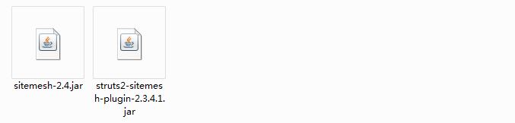

web.xml 中配置
其中一定要在web.xml 中的的配置文件一定要按照一定的顺序来设定，其中配置了这个后，struts的过滤器就可以不用配置了

其中当配置了sitemesh后，struts的配置就不需要了

<!--这个是sitemesh的整合的配置文件-->
<filter>
<filter-name>struts-prepare</filter-name>
<filter-class>org.apache.struts2.dispatcher.ng.filter.StrutsPrepareFilter</filter-class>
</filter>

<filter>
<filter-name>struts-execute</filter-name>
<filter-class>org.apache.struts2.dispatcher.ng.filter.StrutsExecuteFilter</filter-class>
</filter>

<filter>
<filter-name>sitemesh</filter-name>
<filter-class>com.opensymphony.sitemesh.webapp.SiteMeshFilter</filter-class>
</filter>

<filter-mapping>
<filter-name>struts-prepare</filter-name>
<url-pattern>/*</url-pattern>
</filter-mapping>

<filter-mapping>
<filter-name>sitemesh</filter-name>
<url-pattern>/*</url-pattern>
</filter-mapping>

<filter-mapping>
<filter-name>struts-execute</filter-name>
<url-pattern>/*</url-pattern>
</filter-mapping>

<listener>
<listener-class>org.apache.struts2.dispatcher.ng.listener.StrutsListener</listener-class>
</listener>

配置装饰 decorators.xml
decorators.xml

通过这个配置文件，设定那些加上我们呢的sitemesh 那些不加
<?xml version="1.0" encoding="UTF-8"?>

<!--decorators 中的配置了我们的整合页面
/WEB-INF/decorators 目录中添加main.jsp页面
-->
<decorators defaultdir="/WEB-INF/decorators">
<!-- Any urls that are excluded will never be decorated by Sitemesh -->
<excludes>
<pattern>/exclude.jsp</pattern>
<pattern>/exclude/*</pattern>
</excludes>

<!-- 其中我们的装饰的JSP 页面会在WEB-INF 中的decorators中查询我们的页面 -->
<decorator name="main" page="main.jsp">
<pattern>/*</pattern>
</decorator>
</decorators>

设定公共的jsp
在WEB-INF 中建立decorator 子文件夹，添加我们的jsp
其中我们配置了名称为 main.jsp 所以我们需要在decorator文件中添加一个main.jsp

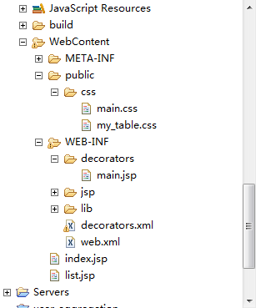

导入sitemesh 中的标签库
<%@ taglib uri="http://www.opensymphony.com/sitemesh/decorator" prefix="decorator" %>

设定 需要添加的类容
<!-- 这个表示的是我们的 sitemesh 中包含的body 部分 -->
<decorator:body/>

main.jsp
<%@ page language="java" contentType="text/html; charset=UTF-8"
pageEncoding="UTF-8"%>
<%@ taglib uri="http://www.opensymphony.com/sitemesh/decorator" prefix="decorator" %>
<%@taglib prefix="s" uri="/struts-tags" %>
<!DOCTYPE html PUBLIC "-//W3C//DTD HTML 4.01 Transitional//EN" "http://www.w3.org/TR/html4/loose.dtd">
<html>
<head>
<meta http-equiv="Content-Type" content="text/html; charset=UTF-8">
<title><decorator:title default="欢迎使用文档管理系统"/></title>
<link rel="stylesheet" type="text/css" href="<%=request.getContextPath()%>/public/css/main.css"/>
<decorator:head/>
</head>
<body>
<s:if test="#session.loginUser!=null">
欢迎[${loginUser.nickname }]登录我们的系统&nbsp;
<s:if test="#session.loginUser.type==1">
<a href="<%=request.getContextPath()%>/user_list.action">用户管理</a>
<a href="<%=request.getContextPath()%>/department_list.action">部门管理</a>
</s:if>
<a href="<%=request.getContextPath()%>/user_updateInput.action?id=${loginUser.id}">修改个人信息</a>&nbsp;
<a href="<%=request.getContextPath()%>/user_show.action?id=${loginUser.id}">个人信息查询</a>&nbsp;
<a href="<%=request.getContextPath()%>/login_loginOut">退出系统</a>
</s:if>
<s:else>
<a href="<%=request.getContextPath()%>/login_loginInput">用户登录</a>
</s:else>
<hr/>
<h3 align="center"><decorator:title default="文档管理系统"/></h3>
<!-- 这个表示的是我们的 sitemesh 中包含的body 部分 -->
<decorator:body/>
<div align="center" style="width:100%;border-top:1px solid; float:left;margin-top:10px;">
CopyRight@2012-2015<br/>
<a href="">狂飙のyellowcong</a>学习项目
</div>
</body>
</html>

当使用了sitemesh 的效果
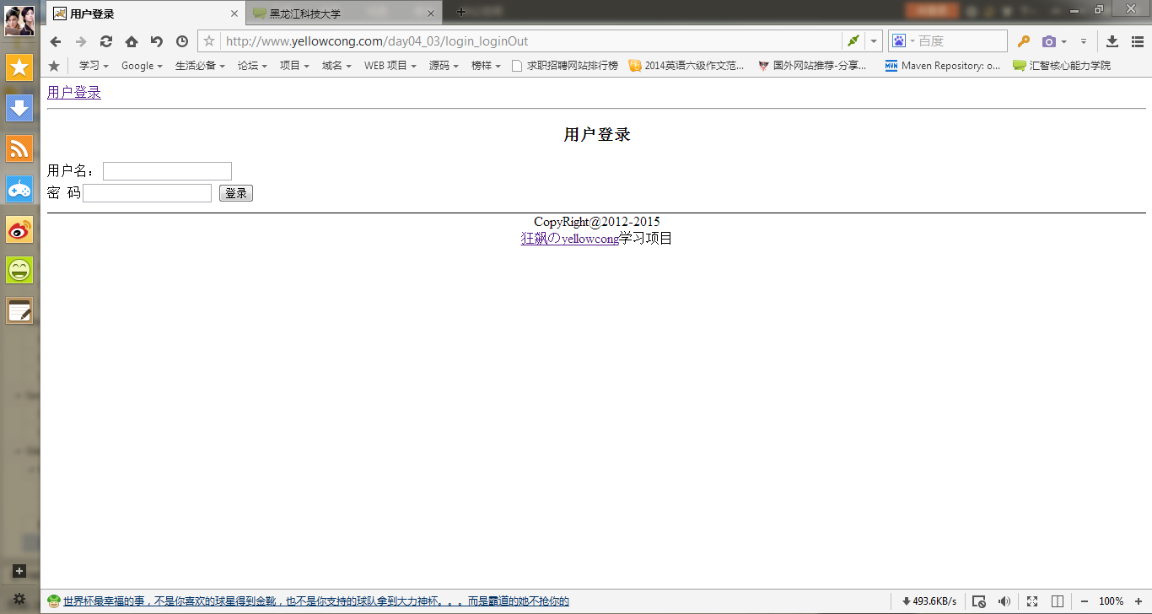

错误信息Unable to load configuration
在没有网络的情况下，sitemesh2.4
2014-4-13 15:21:13 org.apache.catalina.core.AprLifecycleListener init
信息: The APR based Apache Tomcat Native library which allows optimal performance in production environments was not found on the java.library.path: C:\Myeclipse\binary\com.sun.java.jdk.win32.x86_1.6.0.013\bin;.;C:\windows\Sun\Java\bin;C:\windows\system32;C:\windows;D:\maven\nexus\nexus-2.7.2-03-bundle\nexus-2.7.2-03\bin;C:\WINDOWS\system32;C:\apache-maven-3.0.5-bin\apache-maven-3.0.5\bin;D:\Java\ant\apache-ant-1.8.3-bin\apache-ant-1.8.3\bin;C:\Program Files\Java\jdk1.6.0_10\bin;C:\Program Files\MySQL\MySQL Server 5.0\bin;D:\jboss-4.2.3.GA\bin
2014-4-13 15:21:13 org.apache.tomcat.util.digester.SetPropertiesRule begin
警告: [SetPropertiesRule]{Server/Service/Engine/Host/Context} Setting property 'source' to 'org.eclipse.jst.jee.server:day04_03' did not find a matching property.
2014-4-13 15:21:14 org.apache.coyote.http11.Http11Protocol init
信息: Initializing Coyote HTTP/1.1 on http-80
2014-4-13 15:21:14 org.apache.catalina.startup.Catalina load
信息: Initialization processed in 1252 ms
2014-4-13 15:21:14 org.apache.catalina.core.StandardService start
信息: Starting service Catalina
2014-4-13 15:21:14 org.apache.catalina.core.StandardEngine start
信息: Starting Servlet Engine: Apache Tomcat/6.0.33
log4j:WARN No appenders could be found for logger (org.springframework.core.CollectionFactory).
log4j:WARN Please initialize the log4j system properly.
log4j:WARN See http://logging.apache.org/log4j/1.2/faq.html#noconfig for more info.
2014-4-13 15:21:15 org.apache.catalina.core.ApplicationContext log
信息: Initializing Spring root WebApplicationContext
2014-4-13 15:21:25 org.apache.catalina.core.StandardContext listenerStart
严重: Exception sending context initialized event to listener instance of class org.apache.struts2.dispatcher.ng.listener.StrutsListener
Unable to load configuration. - Class: java.net.PlainSocketImpl
File: PlainSocketImpl.java
Method: connect
Line: 177 - java/net/PlainSocketImpl.java:177:-1
at org.apache.struts2.dispatcher.Dispatcher.init(Dispatcher.java:431)
at org.apache.struts2.dispatcher.ng.InitOperations.initDispatcher(InitOperations.java:69)
at org.apache.struts2.dispatcher.ng.listener.StrutsListener.contextInitialized(StrutsListener.java:45)
at org.apache.catalina.core.StandardContext.listenerStart(StandardContext.java:4206)
at org.apache.catalina.core.StandardContext.start(StandardContext.java:4705)
at org.apache.catalina.core.ContainerBase.start(ContainerBase.java:1057)
at org.apache.catalina.core.StandardHost.start(StandardHost.java:840)
at org.apache.catalina.core.ContainerBase.start(ContainerBase.java:1057)
at org.apache.catalina.core.StandardEngine.start(StandardEngine.java:463)
at org.apache.catalina.core.StandardService.start(StandardService.java:525)
at org.apache.catalina.core.StandardServer.start(StandardServer.java:754)
at org.apache.catalina.startup.Catalina.start(Catalina.java:595)
at sun.reflect.NativeMethodAccessorImpl.invoke0(Native Method)
at sun.reflect.NativeMethodAccessorImpl.invoke(NativeMethodAccessorImpl.java:39)
at sun.reflect.DelegatingMethodAccessorImpl.invoke(DelegatingMethodAccessorImpl.java:25)
at java.lang.reflect.Method.invoke(Method.java:597)
at org.apache.catalina.startup.Bootstrap.start(Bootstrap.java:289)
at org.apache.catalina.startup.Bootstrap.main(Bootstrap.java:414)
Caused by: Unable to load configuration. - Class: java.net.PlainSocketImpl
File: PlainSocketImpl.java
Method: connect
Line: 177 - java/net/PlainSocketImpl.java:177:-1
at com.opensymphony.xwork2.config.ConfigurationManager.getConfiguration(ConfigurationManager.java:58)
at org.apache.struts2.dispatcher.Dispatcher.init_PreloadConfiguration(Dispatcher.java:374)
at org.apache.struts2.dispatcher.Dispatcher.init(Dispatcher.java:418)
... 17 more
Caused by: Unable to load jar:file:/D:/Java/Spring%20Code/.metadata/.plugins/org.eclipse.wst.server.core/tmp0/wtpwebapps/day04_03/WEB-INF/lib/struts2-sitemesh-plugin-2.3.4.1.jar!/struts-plugin.xml - Class: java.net.PlainSocketImpl
File: PlainSocketImpl.java
Method: connect
Line: 177 - java/net/PlainSocketImpl.java:177:-1
at com.opensymphony.xwork2.config.providers.XmlConfigurationProvider.loadConfigurationFiles(XmlConfigurationProvider.java:898)
at com.opensymphony.xwork2.config.providers.XmlConfigurationProvider.loadDocuments(XmlConfigurationProvider.java:143)
at com.opensymphony.xwork2.config.providers.XmlConfigurationProvider.init(XmlConfigurationProvider.java:110)
at com.opensymphony.xwork2.config.impl.DefaultConfiguration.reloadContainer(DefaultConfiguration.java:168)
at com.opensymphony.xwork2.config.ConfigurationManager.getConfiguration(ConfigurationManager.java:55)
... 19 more
Caused by: struts.apache.org - Class: java.net.PlainSocketImpl
File: PlainSocketImpl.java
Method: connect
Line: 177 - java/net/PlainSocketImpl.java:177:-1
at com.opensymphony.xwork2.util.DomHelper.parse(DomHelper.java:115)
at com.opensymphony.xwork2.config.providers.XmlConfigurationProvider.loadConfigurationFiles(XmlConfigurationProvider.java:893)
... 23 more
Caused by: java.net.UnknownHostException: struts.apache.org
at java.net.PlainSocketImpl.connect(PlainSocketImpl.java:177)
at java.net.SocksSocketImpl.connect(SocksSocketImpl.java:366)
at java.net.Socket.connect(Socket.java:519)
at java.net.Socket.connect(Socket.java:469)
at sun.net.NetworkClient.doConnect(NetworkClient.java:163)
at sun.net.www.http.HttpClient.openServer(HttpClient.java:394)
at sun.net.www.http.HttpClient.openServer(HttpClient.java:529)
at sun.net.www.http.HttpClient.<init>(HttpClient.java:233)
at sun.net.www.http.HttpClient.New(HttpClient.java:306)
at sun.net.www.http.HttpClient.New(HttpClient.java:323)
at sun.net.www.protocol.http.HttpURLConnection.getNewHttpClient(HttpURLConnection.java:852)
at sun.net.www.protocol.http.HttpURLConnection.plainConnect(HttpURLConnection.java:793)
at sun.net.www.protocol.http.HttpURLConnection.connect(HttpURLConnection.java:718)
at sun.net.www.protocol.http.HttpURLConnection.getInputStream(HttpURLConnection.java:1041)
at com.sun.org.apache.xerces.internal.impl.XMLEntityManager.setupCurrentEntity(XMLEntityManager.java:677)
at com.sun.org.apache.xerces.internal.impl.XMLEntityManager.startEntity(XMLEntityManager.java:1315)
at com.sun.org.apache.xerces.internal.impl.XMLEntityManager.startDTDEntity(XMLEntityManager.java:1282)
at com.sun.org.apache.xerces.internal.impl.XMLDTDScannerImpl.setInputSource(XMLDTDScannerImpl.java:283)
at com.sun.org.apache.xerces.internal.impl.XMLDocumentScannerImpl$DTDDriver.dispatch(XMLDocumentScannerImpl.java:1192)
at com.sun.org.apache.xerces.internal.impl.XMLDocumentScannerImpl$DTDDriver.next(XMLDocumentScannerImpl.java:1089)
at com.sun.org.apache.xerces.internal.impl.XMLDocumentScannerImpl$PrologDriver.next(XMLDocumentScannerImpl.java:1002)
at com.sun.org.apache.xerces.internal.impl.XMLDocumentScannerImpl.next(XMLDocumentScannerImpl.java:648)
at com.sun.org.apache.xerces.internal.impl.XMLNSDocumentScannerImpl.next(XMLNSDocumentScannerImpl.java:140)
at com.sun.org.apache.xerces.internal.impl.XMLDocumentFragmentScannerImpl.scanDocument(XMLDocumentFragmentScannerImpl.java:510)
at com.sun.org.apache.xerces.internal.parsers.XML11Configuration.parse(XML11Configuration.java:807)
at com.sun.org.apache.xerces.internal.parsers.XML11Configuration.parse(XML11Configuration.java:737)
at com.sun.org.apache.xerces.internal.parsers.XMLParser.parse(XMLParser.java:107)
at com.sun.org.apache.xerces.internal.parsers.AbstractSAXParser.parse(AbstractSAXParser.java:1205)
at com.sun.org.apache.xerces.internal.jaxp.SAXParserImpl$JAXPSAXParser.parse(SAXParserImpl.java:522)
at javax.xml.parsers.SAXParser.parse(SAXParser.java:395)
at com.opensymphony.xwork2.util.DomHelper.parse(DomHelper.java:113)
... 24 more
2014-4-13 15:21:25 org.apache.catalina.core.StandardContext start
严重: Error listenerStart
2014-4-13 15:21:25 org.apache.catalina.core.StandardContext start
严重: Context [/day04_03] startup failed due to previous errors
2014-4-13 15:21:25 org.apache.catalina.core.StandardContext listenerStop
严重: Exception sending context destroyed event to listener instance of class org.apache.struts2.dispatcher.ng.listener.StrutsListener
java.lang.NullPointerException
at org.apache.struts2.dispatcher.ng.listener.StrutsListener.contextDestroyed(StrutsListener.java:55)
at org.apache.catalina.core.StandardContext.listenerStop(StandardContext.java:4245)
at org.apache.catalina.core.StandardContext.stop(StandardContext.java:4886)
at org.apache.catalina.core.StandardContext.start(StandardContext.java:4750)
at org.apache.catalina.core.ContainerBase.start(ContainerBase.java:1057)
at org.apache.catalina.core.StandardHost.start(StandardHost.java:840)
at org.apache.catalina.core.ContainerBase.start(ContainerBase.java:1057)
at org.apache.catalina.core.StandardEngine.start(StandardEngine.java:463)
at org.apache.catalina.core.StandardService.start(StandardService.java:525)
at org.apache.catalina.core.StandardServer.start(StandardServer.java:754)
at org.apache.catalina.startup.Catalina.start(Catalina.java:595)
at sun.reflect.NativeMethodAccessorImpl.invoke0(Native Method)
at sun.reflect.NativeMethodAccessorImpl.invoke(NativeMethodAccessorImpl.java:39)
at sun.reflect.DelegatingMethodAccessorImpl.invoke(DelegatingMethodAccessorImpl.java:25)
at java.lang.reflect.Method.invoke(Method.java:597)
at org.apache.catalina.startup.Bootstrap.start(Bootstrap.java:289)
at org.apache.catalina.startup.Bootstrap.main(Bootstrap.java:414)
2014-4-13 15:21:25 org.apache.catalina.core.ApplicationContext log
信息: Closing Spring root WebApplicationContext
2014-4-13 15:21:25 org.apache.catalina.loader.WebappClassLoader clearReferencesJdbc
严重: The web application [/day04_03] registered the JDBC driver [com.mysql.jdbc.Driver] but failed to unregister it when the web application was stopped. To prevent a memory leak, the JDBC Driver has been forcibly unregistered.
2014-4-13 15:21:25 org.apache.catalina.loader.WebappClassLoader clearReferencesThreads
严重: The web application [/day04_03] appears to have started a thread named [Timer-0] but has failed to stop it. This is very likely to create a memory leak.
2014-4-13 15:21:25 org.apache.catalina.loader.WebappClassLoader clearReferencesThreads
严重: The web application [/day04_03] appears to have started a thread named [MySQL Statement Cancellation Timer] but has failed to stop it. This is very likely to create a memory leak.
2014-4-13 15:21:26 org.apache.coyote.http11.Http11Protocol start
信息: Starting Coyote HTTP/1.1 on http-80
2014-4-13 15:21:26 org.apache.jk.common.ChannelSocket init
信息: JK: ajp13 listening on /0.0.0.0:8009
2014-4-13 15:21:26 org.apache.jk.server.JkMain start
信息: Jk running ID=0 time=0/74 config=null
2014-4-13 15:21:26 org.apache.catalina.startup.Catalina start
信息: Server startup in 12716 ms

权限控制

其中权限控制一般会使用Filter来完成，但是我们使用的是Struts，所以可以通过这个来演示一下如何通过拦截器来完成我们的权限控制

其中我们设定了User 对象的type 类型，其中1代表的是我们的是Admin 用户
其中0 代表的是普通用户

普通用户可以访问User 对象的方法
Admin 用户可以访问Department 对象的方法

私人信件管理
Message对象

